Sustainable Public Procurement-fiche: advanced

1) Subject matter

Ornamental plants and trees that are environmentally friendly produced.

“For <…..> (name of the public authority), the care for the environment and social aspects is important. It is stated in her <strategic policies>, <mission>, <vision>, <procurement policy>, …”

2) Exclusion criteria

Non compliance with environmental and social legislation, which has been the subject of a final judgment or a decision having equivalent effect, may be considered an offence concerning the professional conduct of the economic operator concerned or grave misconduct, permitting to exclude the party concerned from competing for the contract

Ref:
Art. 53 and 54 of Directive 2004/17/EC and Art. 45 of Directive 2004/18/EC

3) Technical capacity (not exclusive)
/

4) Technical specifications

Plant characteristics
- [X]% of ornamental plants must be plant species suitable for the local growing conditions (e.g. soil acidity, average rainfall, range of temperature over the year etc.). (Eu toolkit tech spec core criteria)
- [X]%Error: Reference source not found of ornamental plants must be organically produced according to Regulation (EEC) No 2092/91 until 31 December 2008, and Regulation (EC) No 834/2007 as of 1 January 2009. (Eu toolkit tech spec core criteria)

Plant containers
- Plants must be delivered in reusable or biodegradable containers. If plant containers are reusable, the company must take them back after the planting of the plants/trees. (Eu toolkit tech spec comprehensive criteria)
- If plant containers are biodegradable, they must:
  - be made of 100% biodegradable (compostable) substances, such as straw, cork, wood flour, maize starch. (Eu toolkit tech spec comprehensive criteria)
  - not contain synthetic plastic materials, plasticizers or biocide substances, such as found for example in biocides or preservatives. (Eu toolkit tech spec comprehensive criteria)

Packaging

Small plants must be supplied in returnable crates or boxes. (Eu toolkit tech spec comprehensive criteria)

Evidence:

The compliance with the criterion concerning organical production can be proved with the following labels:

Europe:  The Netherlands:  Germany: 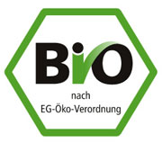

France:  UK: Belgium: 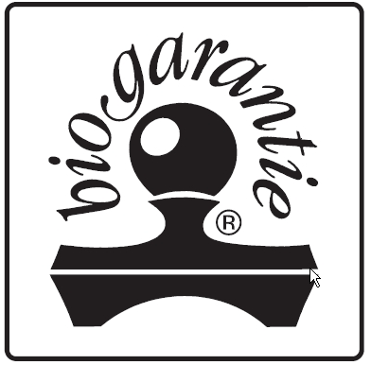
or any other national recognised label on organic production.

In case that the tendering company can present this label, any further proof is not necessary. Any other suitable evidence from a recognized body can also be used.

5) Awarding the contract:

 | Criterium | Weight
1 | Price  Calculation (e.g.): Lowest offered price/ stated price x 0,70 | e.g. 70%
2 | Environmental criteria  (The public authority formulates the points it wants to assign to the below mentioned criteria )  Calculation (e.g.): Total scored points / maximum number of points x 0,20 | e.g. 20%
3 | … | e.g. 5 %
4 | … | e.g. ….

Environmental criteria
/

6) Performance clauses:
/

References

[Information of the public authority that used these clauses in a procurement case]

The X has to be specified by the contracting authority
A list of species considered appropriate has to be mentioned in annex by the procurement. More info about those species in Flanders can be found on the website of the Research Institute for Nature and Forest http://www.inbo.be/docupload/1849.pdf

